Selection: 1

| Please choose a lesson, or type 0 to return to course menu.

1: Introduction 2: Probability1

3: Probability2 4: ConditionalProbability

5: Expectations 6: Variance

7: CommonDistros 8: Asymptotics

9: T Confidence Intervals 10: Hypothesis Testing

11: P Values 12: Power

13: Multiple Testing 14: Resampling

Selection: 10

| Attempting to load lesson dependencies...

| Package ‘ggplot2’ loaded correctly!

| | | 0%

| Hypothesis_Testing. (Slides for this and other Data Science courses may be

| found at github https://github.com/DataScienceSpecialization/courses/. If you

| care to use them, they must be downloaded as a zip file and viewed locally.

| This lesson corresponds to 06_Statistical_Inference/09_HT.)

...

| |= | 1%

| In this lesson, as the name suggests, we'll discuss hypothesis testing which

| is concerned with making decisions about populations using observed data.

...

| |== | 2%

| An important concept in hypothesis testing is the NULL hypothesis, usually

| denoted as H_0. This is the hypothesis that represents the status_quo and is

| assumed true. It's a baseline against which you're testing alternative

| hypotheses, usually denoted by H_a. Statistical evidence is required to

| reject H_0 in favor of the research or alternative hypothesis.

...

| |=== | 4%

| We'll consider the motivating example from the slides. A respiratory

| disturbance index (RDI) of more than 30 events / hour is considered evidence

| of severe sleep disordered breathing (SDB). Suppose that in a sample of 100

| overweight subjects with other risk factors for SDB at a sleep clinic, the

| mean RDI (X') was 32 events / hour with a standard deviation (s) of 10 events

| / hour.

...

| |=== | 5%

| We want to test the null hypothesis H_0 that mu = 30. Our alternative

| hypothesis H_a is mu>30. Here mu represents the hypothesized population mean

| RDI.

...

| |==== | 6%

| So we have two competing hypotheses, H_0 and H_a, of which we'll have to pick

| one (using statistical evidence). That means we have four possible outcomes

| determined by what really is (the truth) and which hypothesis we accept based

| on our data. Two of the outcomes are correct and two are errors.

...

| |===== | 7%

| Which of the following outcomes would be correct?

1: H_0 is FALSE and we accept it

2: H_0 is TRUE and we reject it

3: H_a is TRUE and we accept it

4: H_a is FALSE and we accept it

Selection: 3

| All that hard work is paying off!

| |====== | 8%

| Which of the following outcomes would be an error?

1: H_a is TRUE and we accept it

2: H_a is FALSE and we reject it

3: H_0 is TRUE and we reject it

4: H_0 is FALSE and we reject it

Selection: 3

| Excellent work!

| |======= | 10%

| So it's correct to accept a true hypothesis or reject a false one. Pretty

| clear, right?

...

| |======== | 11%

| The errors are also clear - rejecting a true hypothesis or accepting a false

| one.

...

| |======== | 12%

| We distinguish between these two errors. A Type I error REJECTS a TRUE null

| hypothesis H_0 and a Type II error ACCEPTS a FALSE null hypothesis H_0.

...

| |========= | 13%

| Can we ever be sure that we're absolutely right?

1: No

2: Always

3: Yes

4: Let's not get into philosophy now

Selection: 1

| You are amazing!

| |========== | 14%

| Since there's some element of uncertainty in questions concerning

| populations, we deal with probabilities. In our hypothesis testing we'll set

| the probability of making errors small. For now we'll focus on Type I errors,

| rejecting a correct hypothesis.

...

| |=========== | 16%

| The probabilities of making these two kinds of errors are related. If you

| decrease the probability of making a Type I error (rejecting a true

| hypothesis), you increase the probability of making a Type II error

| (accepting a false one) and vice versa.

...

| |============ | 17%

| As in the slides, we'll consider an American court of law. The null

| hypothesis is that the defendant is innocent. If an innocent man is convicted

| what type of error is this?

1: Type I

2: Type II

Selection: 1

| You got it!

| |============= | 18%

| You might send the innocent man to jail by rejecting H_0. Suppose a guilty

| person is not convicted. What type of error is this?

1: Type I

2: Type II

Selection: 2

| You nailed it! Good job!

| |============= | 19%

| Back to sleep (example)! A reasonable strategy would reject the null

| hypothesis if our sample mean X' was larger than some constant C. We choose C

| so that the probability of a Type I error, alpha, is .05 (or some other

| favorite constant). Many scientific papers use .05 as a standard level of

| rejection.

...

| |============== | 20%

| This means that alpha, the Type I error rate, is the probability of rejecting

| the null hypothesis when, in fact, it is correct. We don't want alpha too low

| because then we would never reject the null hypothesis even if it's false.

...

| |=============== | 22%

| Recall that the standard error of a sample mean is given by the formula

| s/sqrt(n). Recall in our sleep example we had a sample of 100 subjects, our

| mean RDI (X') was 32 events / hour with a standard deviation (s) of 10 events

| / hour. What is the standard error of the mean in this example?

> 10/sqrt(100)

[1] 1

| Excellent work!

| |================ | 23%

| Under H_0, X' is normally distributed with mean mu=30 and variance 1. (We're

| estimating the variance as the square of the standard error which in this

| case is 1.) We want to choose the constant C so that the probability that X

| is greater than C given H_0 is 5%. That is, P(X > C| H_0) is 5%. Sound

| familiar?

... 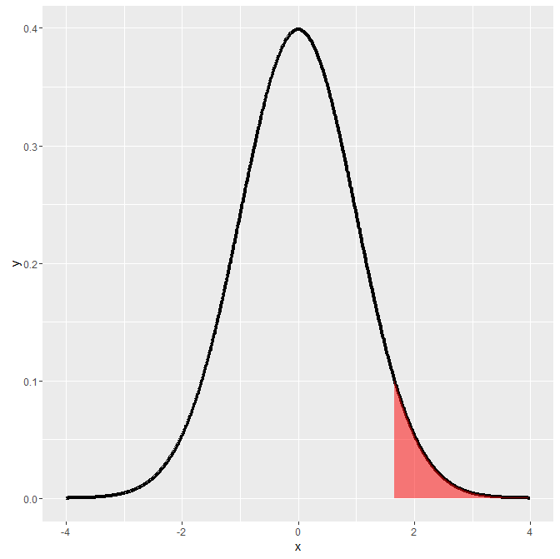

| |================= | 24%

| Here's a plot to show what we mean. The shaded portion represents 5% of the

| area under the curve and those X values in it are those for which the

| probability that X>C is 5%.

...

| |================== | 25%

| The shaded portion represents 5% of the area under this normal density curve.

| Which expression represents the smallest value X for which the area is

| shaded, assuming this is standard normal?

1: rnorm(.95)

2: qt(.95,99)

3: dnorm(.95)

4: qnorm(.95)

Selection: 4

| You're the best!

| |=================== | 27%

| The 95th percentile of a standard normal distribution is 1.645 standard

| deviations from the mean, so in our example we have to set C to be 1.645

| standard deviations MORE than our hypothesized mean of 30, that is, C = 30 +

| 1.645 * 1 = 31.645 (recall that the variance and standard deviation equalled

| 1).

...

| |=================== | 28%

| This means that if our OBSERVED (sample) mean X' >= C, then it's only a 5%

| chance that a random draw from this N(30,1) distribution is larger than C.

...

| |==================== | 29%

| Recall that our observed mean X' is 32 which is greater than C=31.645, so it

| falls in that 5% region. What do we do with H_0?

1: fail to reject it

2: reject it

3: give it another chance

Selection: 2

| You got it right!

| |===================== | 30%

| So the rule "Reject H_0 when the sample mean X' >= 31.645" has the property

| that the probability of rejecting H_0 when it is TRUE is 5% given the model

| of this example - hypothesized mean mu=30, variance=1 and n=100.

...

| |====================== | 31%

| Instead of computing a constant C as a cutpoint for accepting or rejecting

| the null hypothesis, we can simply compute a Z score, the number of standard

| deviations the sample mean is from the hypothesized mean. We can then compare

| it to quantile determined by alpha.

...

| |======================= | 33%

| How do we do this? Compute the distance between the two means (32-30) and

| divide by the standard error of the mean, that is (s/sqrt(n)).

...

| |======================== | 34%

| What is the Z score for this example? Recall the Z score is X'-mu divided by

| the standard error of the mean. In this example X'=32, mu=30 and the standard

| error is 10/sqrt(100)=1.

> 32-30/(10/sqrt(100))

[1] 2

| All that hard work is paying off!

| |======================== | 35%

| The Z score is 2. The quantile is 1.645, so since 2>1.645. What do we do with

| H_0?

1: give it another chance

2: reject it

3: fail to reject it

Selection: 2

| Excellent work!

| |========================= | 36%

| The general rule for rejection is if sqrt(n) * ( X' - mu) / s > Z_{1-alpha}.

...

| |========================== | 37%

| Our test statistic is (X'-mu) / (s/sqrt(n)) which is standard normal.

...

| |=========================== | 39%

| This means that our test statistic has what mean and standard deviation?

1: 0 and 0

2: 1 and 0

3: 0 and 1

4: 1 and 1

Selection: 3

| That's a job well done!

| |============================ | 40%

| Let's review and expand. Our null hypothesis is that the population mean mu

| equals the value mu_0 and alpha=.05. (This is the probability that we reject

| H_0 if it's true.) We can have several different alternative hypotheses.

...

| |============================= | 41%

| Suppose our first alternative, H_a, is that mu < mu_0. We would reject H_0

| (and accept H_a) when our observed sample mean is significantly less than

| mu_0. That is, our test statistic (X'-mu) / (s/sqrt(n)) is less than Z_alpha.

| Specifically, it is more than 1.64 standard deviations to the left of the

| mean mu_0.

... 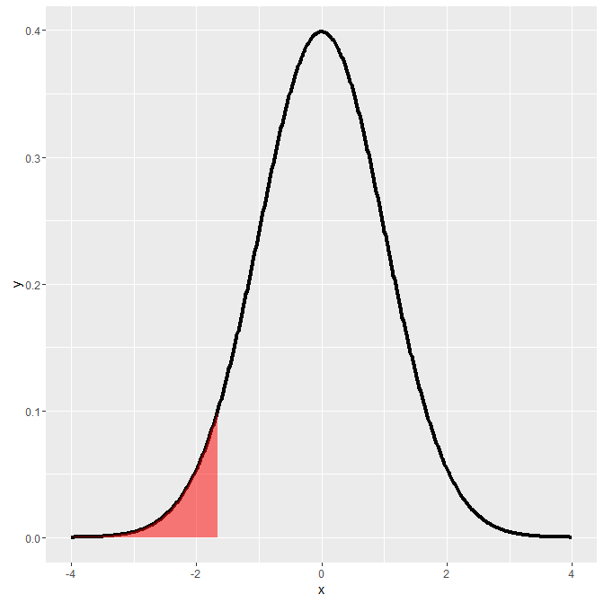

| |============================== | 42%

| Here's a plot to show what we mean. The shaded portion represents 5% of the

| area under the curve and those X values in it are those which are at least

| 1.64 standard deviations less than the mean. The probability of this is 5%.

| This means that if our sample mean fell in this area, we would reject a true

| null hypothesis, mu=mu_0, with probability 5%.

...

| |============================== | 43%

| We already covered the alternative hypothesis H_a that mu > mu_0 but let's

| review it. We would reject H_0 (and accept H_a) when our sample mean is what?

1: huh?

2: significantly less than mu_0

3: significantly greater than mu_0

4: equal to mu_0

Selection: 3

| Excellent job!

| |=============================== | 45%

| This means that our test statistic (X'-mu) / (s/sqrt(n)) is what?

1: huh?

2: at least 1.64 std dev less than mu_0

3: equal to mu_0

4: at least 1.64 std dev greater than mu_0

Selection: 4

| You nailed it! Good job!



| |================================ | 46%

| Here again is the plot to show this. The shaded portion represents 5% of the

| area under the curve and those X values in it are those which are at least

| 1.64 standard deviations greater than the mean. The probability of this is

| 5%. This means that if our observed mean fell in this area we would reject a

| true null hypothesis, that mu=mu_0, with probability 5%.

...

| |================================= | 47%

| Finally, let's consider the alternative hypothesis H_a that mu is simply not

| equal to mu_0, the mean hypothesized by the null hypothesis H_0. We would

| reject H_0 (and accept H_a) when our sample mean is significantly different

| than mu_0, that is, either less than OR greater than mu_0.

...

| |================================== | 48%

| Since we want to stick with a 5% rejection rate, we divide it in half and

| consider values at both tails, at the .025 and the .975 percentiles. This

| means that our test statistic (X'-mu) / (s/sqrt(n)) is less than .025,

| Z_(alpha/2), or greater than .975, Z_(1-alpha/2).

... 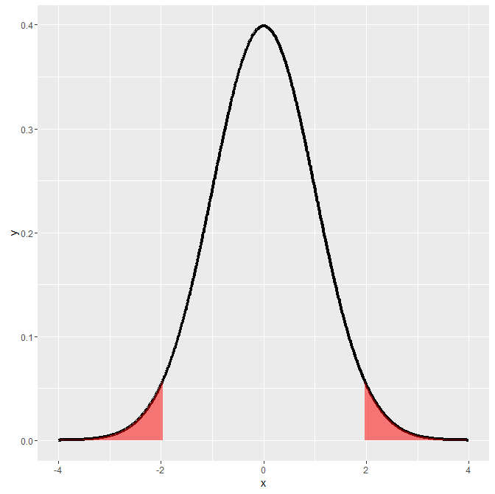

| |=================================== | 49%

| Here's the plot. As before, the shaded portion represents the 5% of the area

| composing the region of rejection. This time, though, it's composed of two

| equal pieces, each containing 2.5% of the area under the curve. The X values

| in the shaded portions are values which are at least 1.96 standard deviations

| away from the hypothesized mean.

...

| |=================================== | 51%

| Notice that if we reject H_0, either it was FALSE (and hence our model is

| wrong and we are correct to reject it) OR H_0 is TRUE and we have made an

| error (Type I). The probability of this is 5%.

...

| |==================================== | 52%

| Since our tests were based on alpha, the probability of a Type I error, we

| say that we "fail to reject H_0" rather than we "accept H_0". If we fail to

| reject H_0, then H_0 could be true OR we just might not have enough data to

| reject it.

...

| |===================================== | 53%

| We have not fixed the probability of a type II error (accepting H_0 when it

| is false), which we call beta. The term POWER refers to the quantity 1-beta

| and it represents the probability of rejecting H_0 when it's false. This is

| used to determine appropriate sample sizes in experiments.

...

| |====================================== | 54%

| What do you think we call the region of values for which we reject H_0?

1: the rejection region

2: the region of interest

3: the shady tails

4: the abnormal region

5: the waggy tails

Selection: 1

| You are amazing!

| |======================================= | 55%

| Note that so far we've been talking about NORMAL distributions and implicitly

| relying on the CENTRAL LIMIT THEOREM (CLT).

...

| |======================================== | 57%

| Remember the CLT. For a distribution to be approximated by a normal what does

| the sample size have to be?

1: abnormal

2: normal

3: small

4: large

Selection: 4

| That's correct!

| |======================================== | 58%

| No need to worry. If we don't have a large sample size, we can use the t

| distribution which conveniently uses the same test statistic (X'-mu) /

| (s/sqrt(n)) we used above. That means that all the examples we just went

| through would work exactly the same EXCEPT instead of using NORMAL quantiles,

| we would use t quantiles and n-1 degrees of freedom.

...

| |========================================= | 59%

| We said t distributions were very handy, didn't we?

...

| |========================================== | 60%

| Let's go back to our sleep disorder example and suppose our sample size=16

| (instead of 100). As before, (sample mean) X'=32, (standard deviation) s=10.

| H_0 says the true mean mu=30, and H_a is that mu>30. With this smaller sample

| size we use the t test, but our test statistic is computed the same way,

| namely (X'-mu)/(s/sqrt(n))

...

| |=========================================== | 61%

| What is the value of the test statistic (X'-mu)/(s/sqrt(n)) with sample size

| 16?

> (32-30)/(10/sqrt(16))

[1] 0.8

| Excellent work!

| |============================================ | 63%

| How many degrees of freedom do we have with a sample size of 16?

> 16-1

[1] 15

| Excellent job!

| |============================================= | 64%

| Under H_0, the probability that the test statistic is larger than the 95th

| percentile of the t distribution is 5%. Use the R function qt with the

| arguments .95 and the correct number of degrees of freedom to find the

| quantile.

> qt(.95, 15)

[1] 1.75305

| You are amazing!

| |============================================== | 65%

| So the test statistic (.8) is less than 1.75, the 95th percentile of the t

| distribution with 15 df. This means that our sample mean (32) does not fall

| within the region of rejection since H_a was that mu>30.

...

| |============================================== | 66%

| This means what?

1: we fail to reject H_0

2: we reject H_0

3: we reject H_a

Selection: 2

| That's not the answer I was looking for, but try again.

| The test statistic is outside the region of rejection so we fail to reject

| H_0.

1: we fail to reject H_0

2: we reject H_a

3: we reject H_0

Selection: 1

| You got it right!

| |=============================================== | 67%

| Now let's consider a two-sided test. Suppose that we would reject the null

| hypothesis if in fact the sample mean was too large or too small. That is, we

| want to test the alternative H_a that mu is not equal to 30. We will reject

| if the test statistic, 0.8, is either too large or too small.

...

| |================================================ | 69%

| As we discussed before, we want the probability of rejecting under the null

| to be 5%, split equally as 2.5% in the upper tail and 2.5% in the lower tail.

| Thus we reject if our test statistic is larger than qt(.975, 15) or smaller

| than qt(.025, 15).

...

| |================================================= | 70%

| Do you expect qt(.975,15) to be bigger or smaller than qt(.95,15)?

1: bigger

2: smaller

Selection: 1

| That's correct!

| |================================================== | 71%

| Since the test statistic was smaller than qt(.95,15) will it be bigger or

| smaller than qt(.975,15)?

1: bigger

2: smaller

Selection: 2

| Nice work!

| |=================================================== | 72%

| Now for the left tail, qt(.025,15). What can we say about it?

1: it is bigger than qt(.975,15)

2: it is less than 0

3: it is greater than 0

4: we don't know anything about it

Selection: 2

| You're the best!

| |=================================================== | 73%

| Bottom line here is if you fail to reject the one sided test, you know that

| you will fail to reject the two sided.

...

| |==================================================== | 75%

| So the test statistic .8 failed both sides of the test. That means we ?

1: fail to reject H_0

2: reject H_0

3: huh?

4: reject H_a

Selection: 1

| You got it right!

| |===================================================== | 76%

| Now we usually don't have to do all this computation ourselves because R

| provides the function t.test which happily does all the work! To prove this,

| we've provided a csv file with the father_son height data from John Verzani's

| UsingR website (http://wiener.math.csi.cuny.edu/UsingR/) and read it into a

| data structure fs for you. We'll do a t test on this paired data to see if

| fathers and sons have similar heights (our null hypothesis).

...

| |====================================================== | 77%

| Look at the dimensions of fs now using the R function dim.

> dim(fs)

[1] 1078 2

| You got it right!

| |======================================================= | 78%

| So fs has 1078 rows and 2 columns. The columns, fheight and sheight, contain

| the heights of a father and his son. Obviously there are 1078 such pairs. We

| can run t.test on this data in one of two ways. First, we can run it with

| just one argument, the difference between the heights, say

| fs$sheight-fs$fheight. OR we can run it with three arguments, the two heights

| plus the paired argument set to TRUE. Run t.test now using whichever way you

| prefer.

> t.test(fs$sheight-fs$fheight)

One Sample t-test

data: fs$sheight - fs$fheight

t = 11.789, df = 1077, p-value < 2.2e-16

alternative hypothesis: true mean is not equal to 0

95 percent confidence interval:

0.8310296 1.1629160

sample estimates:

mean of x

0.9969728

| You are quite good my friend!

| |======================================================== | 80%

| The test statistic is what?

1: 11.7885

2: 0.9969728

3: .8310296

4: 2.2e-16

Selection: 1

| All that practice is paying off!

| |========================================================= | 81%

| So the test statistic is 11.79 which is quite large so we REJECT the null

| hypothesis that the true mean of the difference was 0 (if you ran the test on

| the difference sheight-fheight) or that the true difference in means was 0

| (if you ran the test on the two separate but paired columns).

...

| |========================================================= | 82%

| The test statistic tell us what?

1: the sample mean

2: the number of estimated std errors between the sample and hypothesized means

3: the true mean

4: the true variance

Selection: 2

| You are amazing!

| |========================================================== | 83%

| We can test this by multiplying the t statistic (11.7885) by the standard

| deviation of the data divided by the square root of the sample size.

| Specifically run 11.7885 * sd(fs$sheight-fs$fheight)/sqrt(1078).

> 11.7885 * sd(fs$sheight-fs$fheight)/sqrt(1078)

[1] 0.9969686

| All that hard work is paying off!

| |=========================================================== | 84%

| This should give you a close match to the mean of x which t.test gave you,

| 0.9969728.

...

| |============================================================ | 86%

| Note the 95% confidence interval, 0.8310296 1.1629160, returned by t.test. It

| does not contain the hypothesized population mean 0 so we're pretty confident

| we can safely reject the hypothesis. This tells us that either our hypothesis

| is wrong or we're making a mistake (Type 1) in rejecting it.

...

| |============================================================= | 87%

| You've probably noticed the strong similarity between the confidence

| intervals we studied in the last lesson and these hypothesis tests. That's

| because they're equivalent!

...

| |============================================================== | 88%

| If you set alpha to some value (say .05) and ran many tests checking

| alternative hypotheses against H_0, that mu=mu_0, the set of all possible

| values for which you fail to reject H_0 forms the (1-alpha)% (that is 95%)

| confidence interval for mu_0.

...

| |============================================================== | 89%

| Similarly, if a (1-alpha)% interval contains mu_0, then we fail to reject

| H_0.

...

| |=============================================================== | 90%

| Let's see how hypothesis testing works with binomial distributions by

| considering the example from the slides. A family has 8 children, 7 of whom

| are girls and none are twins. Let the null hypothesis be that either gender

| is equally likely, like an iid coin flip.

...

| |================================================================ | 92%

| So our H_0 is that p=.5, where p is the probability of a girl. We want to see

| if we should reject H_0 based on this sample of size 8. Our H_a is that p>.5,

| so we'll do a one-sided test, i.e., look at only the right tail of the

| distribution.

...

| |================================================================= | 93%

| Let's set alpha, the level of our test, to .05 and find the probabilities

| associated with different rejection regions, where a rejection region i has

| at least i-1 girls out of a possible 8.

...

| |================================================================== | 94%

| We've defined for you a 9-long vector, mybin, which shows nine probabilities,

| the i-th of which is the probability that there are at least i-1 girls out of

| the 8 possible children. Look at mybin now.

> mybin

[1] 1.00000000 0.99609375 0.96484375 0.85546875 0.63671875 0.36328125 0.14453125

[8] 0.03515625 0.00390625

| You're the best!

| |=================================================================== | 95%

| So mybin[1]=1.0, meaning that with probability 1 there are at least 0 girls,

| and mybin[2]=.996 is the probability that there's at least 1 girl out of the

| 8, and so forth. The probabilities decrease as i increases. What is the least

| value of i for which the probability is less than .05?

> 8

[1] 8

| That's the answer I was looking for.

| |=================================================================== | 96%

| So mybin[8]=.03 is the probability of having at least 7 girls out of a sample

| of size 8 under H_0 (if p actually is .5) which is what our sample has. This

| is less than .05 so our sample falls in this region of rejection. Does that

| mean we accept or reject H_0, (that either gender is equally likely) based on

| this sample of size 8?

1: accept H_0

2: reject H_0

Selection: 2

| You got it right!

| |==================================================================== | 98%

| Finally, we note that a 2-sided test would mean that our alternative

| hypothesis is that p is not equal to .5, and it's not obvious how to do this

| with a binomial distribution. Don't worry, though, because the next lesson on

| p-values will make this clearer. It's interesting that for discrete

| distributions such as binomial and Poisson, inverting 2-sided tests is how R

| calculates exact tests. (It doesn't rely on the CLT.)

...

| |===================================================================== | 99%

| Congrats! We confidently hypothesize that you're happy to have finished this

| lesson. Can we test this?

...

| |======================================================================| 100%

| Would you like to receive credit for completing this course on Coursera.org?

1: No

2: Yes

Selection: 2

What is your email address? sweeyean@gmail.com

What is your assignment token? Z7EKwnFfGJhfhJPn

Grade submission succeeded!

| Excellent job!

| You've reached the end of this lesson! Returning to the main menu...

| Please choose a course, or type 0 to exit swirl.

1: Statistical Inference

2: Take me to the swirl course repository!

Selection: